Jim King

22 Patriots Way, Somerset, NJ 08873

jimking@mac.com www.jimkingphoto.com
Name | Phone
Address | Email
Player Name | Player Number | Check one: ___Varsity ___JV __Freshman

Prints  5x7 - $9  8x10 - $15  11x14 - $22  12x18 - $34  16x20 - $45  20x30 - $60  4 wallets - $9  Be sure to identify the photo with the game date and DSC number  ex. 22.01.10_delv_v_cha_DSC1234 | Digital Files  High Resolution Digital Files in a shared folder for download  $20 per photo/ 5 Photos $75/ 10 Photos $100  Super Package Digital Files in a shared folder for download  25 high & low resolution photos for print, web or social media  & player web gallery $150  Full Season/Large Number of Digital Files (same player)  Contact me for special discounted price  Player Web Gallery up to 25 photos posted on my website $50  Team and group shot digital files are not available for sale
Collages  Player Collage* 16x20 $120  5 photos with mascot name, player name & number  7 Photo Team Collage* 6x20 $105  7 photos with team name, player name & number  7 Photo Player Silhouette Collage* 16x20 $105  7 photos with player name & number  Single Photo Collage* 11x14 $48 / 16x20 $60  Comes in 4 different styles: Color, Selective Color, Sepia, B&W  Posed & Action Photo Collage 11x14 $48, 16x20 $60  Triptych 18x24 $105  3 photos with player name & number. Comes in 4 different styles:  Color, Selective Color, Sepia, Black & White  * For Collages you can select the photos or allow me to. A digital proof of the collage will be sent for your approval before printing. | Packages  PKG #1 Team Photo with School, Team, Season Date & Logo  8x10 $14, 11x14 $20, 16x20 $40  PKG #2 Basic Sports Package $24 (same photo)  1 - 8x10 Team, 1 - 5x7, 4 – wallets  PKG #3 Team & Posed or Action Photo Composite with  Team, Season & Team Logo  8x10 $22, 11x14 $32, 16x20 $48  PKG #4 Mix & Match Team Photo with any Combination of  Posed & Action Photos  1 - 8x10 team, 1 - 8x10, 2 – 5x7’s (same photo), 8 – wallets $40  PKG #5 Senior Package $28  1 - 5x7 Senior Player with Parents, 1 - 8x10 Senior Group,  1 - 8x10 Varsity Team Photo  Statuette - 1 player, metallic print on black Plexiglas 8x10 $45

List Package #, Collage Name,  Digital Files or Prints  Ex. Prints | Game Date/Team  Photo DSC #(s)  Ex. 19.10.15_mov_v_ran DSC1234 | Print Size  Ex. 5x7 | QTY  Ex. 2 | Price  Ex. $8 | Total  Ex. $16
Frame 8x10 - $20, 11x14 - $30, 16x20 - $45, 18x24 - $50
Total

Complete this order form and attach it to an email to jimking@mac.com or mail to Jim King at the above address.
When ordering be sure to write exact date, game & DSC # found below large photo on web site. Feel free to attach additional sheets for large orders.

You may pay by cash, Venmo (jimking24) or check made out to Jim King

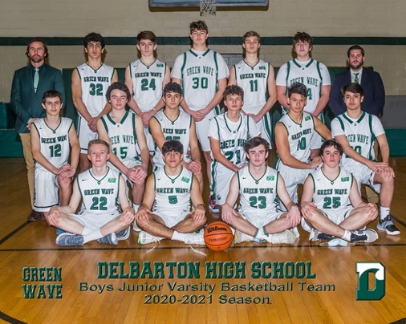  Package #1 Team Photo with Team Name, Season & Team Logo  Available in 8x10, 11x14, 16x20 | 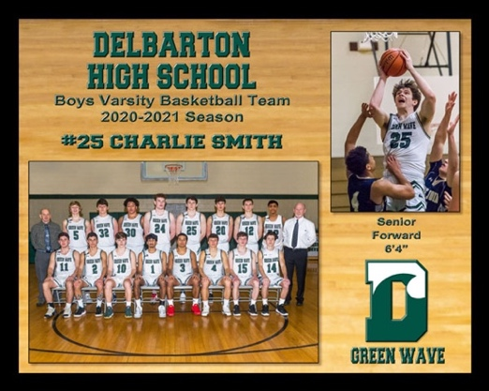  Package #3 - Team & Posed or Action Photo Composite with Team Name, Season & Logo  Available in 8x10, 11x14, 16x20 | 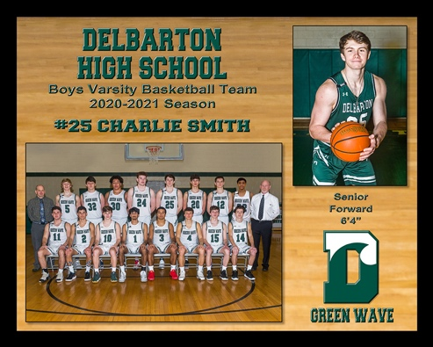  Package #3 - Team & Posed or Action Photo Composite with Team Name, Season & Logo  Available in 8x10, 11x14, 16x20
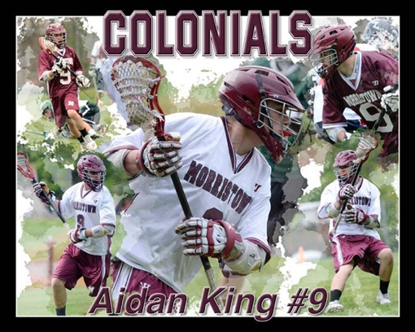  Player Collage – 16x20 | 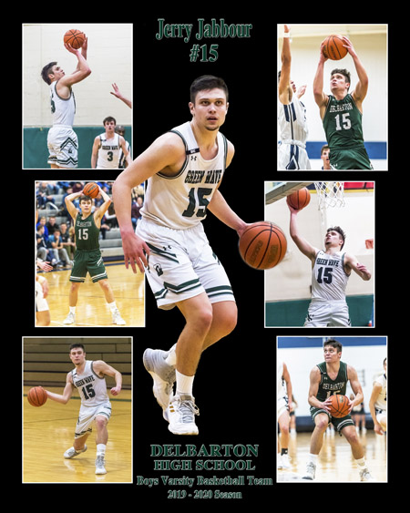  7 Photo Player Silhouette Collage - 16x20 | 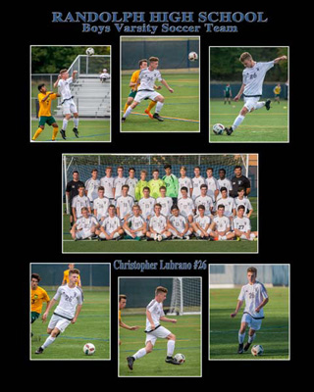  7 Photo Player Team Collage - 16x20
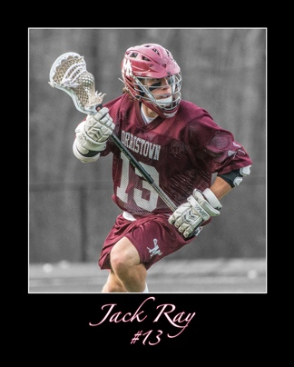  Single Photo Collage 11x14, 16x20  Available in Color, Sepia, or B&W | 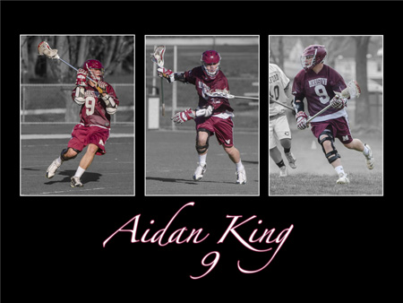  Selective Color Triptych 18x24  Available in Color, Sepia, or B&W | 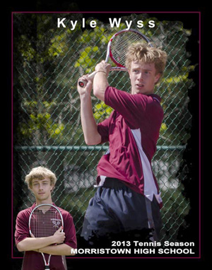  Posed & Action Photo Collage  Available in 11x14, 16x20
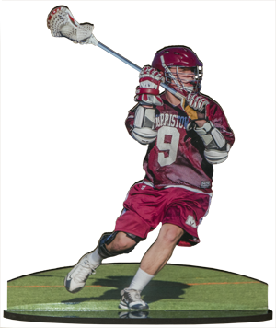  Statuette – 8x10 metallic print  on black Plexiglas | 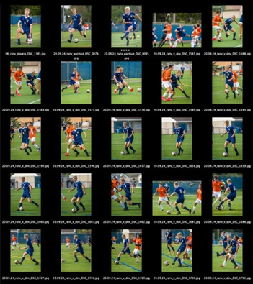  Complimentary Digital Contact  index of photos of a single player

